**Modelling biomarker information**

**Challenges:**

* The importance of the context: a biomarker can be measured with different assays and have more than one use, depending on an association with a specific disease, as described in the provided evidence.
* Sets, panels or combinatorial markers: can contain multiple markers, either within the same assay or a combination of different assays. In other words, there is no 1-1 relationship between all biomarker attributes (described in minimal information document)
* There is more than one classification system for a BM (by usage, concept, status, or assessment type)

**The model:**

* A single or composite biomarker belongs to 2 classes, corresponding with different classification systems (by its purpose, or usage, and by the nature or its measurement, called type).
* A complex biomarker, consists of independent measurements. It belongs to ComplexBM class and contains (links to) many instances of a Biomarker (can be a combinations of different types)
* Disease, Assay/Test, AnatomicalEntity(source/location) and Treatment are currently local classes but represent entities in external ontologies (as described in Biomarker Minimum Information document)

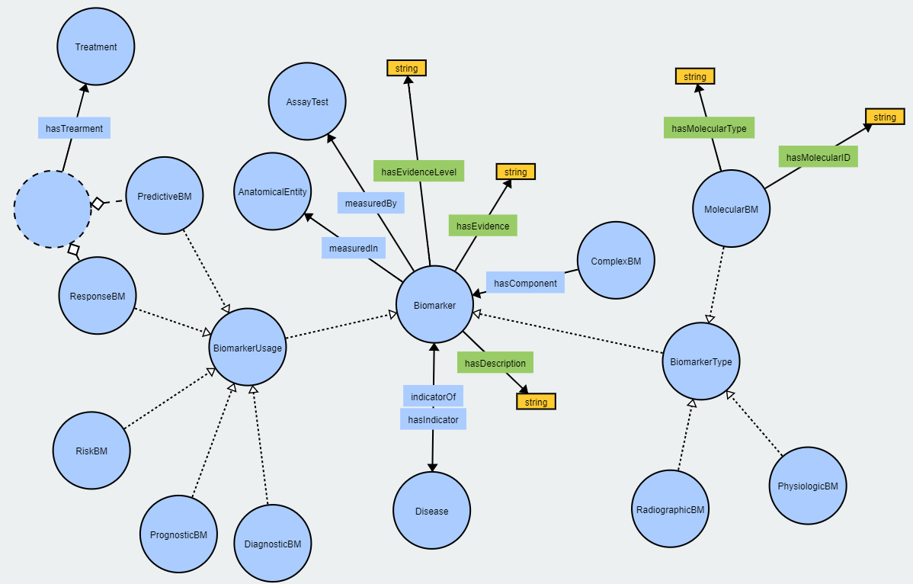

**Remarks / future development:**

* Evidence level refers to the biomarker status and is not well defined at the moment
* So far the focus has been on molecular biomarkers, in the future properties relevant to other types (physiologic, radiographic) should be added